APPENDIX F
Finals Documentation

Appendix F contains copies of the Finals documents associated with Chapter 11 of the Local Agency Project Desk Reference.

Local Agency Final Construction Acceptance Certification
CDOT Letter of Materials Certification
EEO Certification Acceptance Letter
Guidance for Acceptance, Advertisement and Finaling of Local Agency Projects
Final Documentation Checklist
Final Materials Documentation Checklist
CDOT Form 90 – Contract Modification Order
CDOT Form 96 – Contractor Acceptance of Final Estimate
CDOT Form 1418 – Monthly Payment Summary
CDOT Form 1419 – DBE Participation Report

LOCAL AGENCY
FINAL CONSTRUCTION ACCEPTANCE CERTIFICATION

Project Number: _______________________ ID# _____________
Project Location:___________________________________________________________
Contractor’s Name: ________________________________________________________
Original Contract Amount $: _________________ Final Contract Amount $:__________________
Project Acceptance Date: _________________
(To be initialed by the local agency Licensed Project Engineer in responsible charge of the project)

I hereby certify that:
_____ The project has been completed in reasonably close conformity with plans and
specifications including authorized changes. The Entity accepts the project as complete.
_____ The completed project has been reviewed for obvious safety deficiencies.
_____ The project R.O.W. appears to be free of unauthorized encroachments.
_____ The materials test results indicate that the materials incorporated in the project
were in conformity with the approved plans and specifications with :
_____ no exception _____ exceptions (explanation attached)
_____ All required material COCs have been received.
*_____ CDOT Form 379 has been completed. _____ Yes _____ No
*_____ CDOT Form 250 has been completed. _____ Yes _____ No
*_____ Letter of Materials Certification (CDOT 473) has been completed. _____ Yes _____ No
**_____The EEO Certification Letter has been completed.
**_____CDOT Form 1419 has been received.
*_____ Buy America Statement has been received.
*_____ All change orders have been submitted to the CDOT RE for review and approval.
*_____ The Contractor has agreed to the final payment as full and complete.(May use CDOT Form 96)
*_____ The Local Agency Final Acceptance Letter has been issued.
*_____ Final Bill and Closure Letter has been issued.
*_____ As Constructed Plans have been completed.
*_____ Notice of Final Settlement has been made.
______ The Local Agency will retain all project pay documentation and forms per Federal Regulations, Public records law and CRS 24-72-201 through CRS 24-72-206.
______ The Contractor has filed a claim ___No ___Yes

Signature of Entity Official_________________________________ Date_________
Title_____________________________________
* indicates a copy of this form is to be submitted to CDOT
** a copy of this form is to be submitted to the CDOT Region EEO
Original to: CDOT RE Cc. Local Agency Resident Engineer
Colorado Department of Transportation
LETTER OF MATERIALS CERTIFICATION

Project Number: _____________________
Location: ___________________________
Project Code: ________________________
Date: _______________________________
Contractor: __________________________
Date Accepted: _______________________

This is to certify that:

The results of the tests on acceptance samples indicate that the material incorporated in the construction work, and the construction operations controlled by sampling and testing, were in conformity with the approved plans and specifications; and such results compare favorably with the results of the independent Assurance Sampling and Testing.

All independent Assurance sample and tests are within tolerance limits of these samples and tests that are used in the acceptance program, except as documented in the project records.

Exceptions to the plans and specifications are explained on the back hereof (or on an attached sheet).

Page 2 attached, Explanation(s) of Exceptions.
Page 3 attached, Independent Assurance Schedule.

The Independent Assurance System Basis Program used for Hot Bituminous Pavements does not apply on Region 6 projects.

By _________________________________

Local Agency Engineer

Cc:
Local Agency Resident Engineer
CDOT Resident Engineer
CDOT Materials Engineer
CDOT Central Files

EEO CERTIFICATION ACCEPTANCE LETTER

Date:
To: CDOT Region X Resident Engineer

From:
Subject: EEO Certification of Compliance

Project No.:
ID#:

I do hereby certify:

All contractor certified payroll documentation has been reviewed and is in compliance.

All federally mandated EEO Program documentation has been reviewed and is in compliance.
(includes subletting, monthly employee interviews, Colorado Program and OJT.)

All documentation will be retained for the required length of time per the FHWA 1273.

Comments/Explanation of Exceptions that apply:
______________________________________________________________________________________________________________________________________________________________________________________________________________________________________________________________________________________________________________________________________________________________________________________________________________________________________________________

Certified By:

________________________________ ______________________________
Local Agency Representative Title

Cc:
Local Agency Resident Engineer
CDOT EEO Representative

The three (3) previous documents must be completed by a representative of the Local Agency in responsible charge of the project and submitted to the CDOT RE.

The following pages are included for information and convenience.

Acceptance, Advertisement and Finaling of Local Agency Projects

PROJECT ACCEPTANCE AND ADVERTISEMENT:

- The Local Agency shall notify the CDOT Project Manager and CDOT RE 2-3 weeks prior to completion of project to schedule a final walk through. It is also recommended that the environmental, maintenance and traffic sections also be included in the final walk through.
- Upon acceptance, the Local Agency writes the letter of acceptance to the Contractor. This letter should list all documentation that is still outstanding. There is an example in the CDOT Construction Manual, Appendix B. Original to Contractor, copy to CDOT RE.
- The Local Agency advertises the project for Final Settlement. This is required by 38-26-107 CRS to be published twice in a publication where the project physically resides. A copy of the Notice of Final Settlement should be sent to CDOT RE, Staff ROW, Project Development.
- The CDOT RE shall complete the DOT 1212. Distribution shall include a copy to the Local Agency.

The following are the responsibility of the Local Agency:

“AS CONSTRUCTED” PLANS
- Assure the “As Constructed” plans are complete and also includes:
  - Location of all underground obstructions.
  - All utility locations.
  - Any changes to the typical section.
  - Manufacture and type of bridge expansion devices.
  - Vertical and Lateral clearances of structures.
- Guidelines are available in the CDOT 2002 Construction Manual, Section 121.
- Send one (1) set to the CDOT RE. Two (2) sets if the project is on the NHS.
- Send one (1) set to Staff Bridge if construction includes a major or minor structure.

MATERIALS FINAL

- LA engineer or the materials head tester completes the “Final Materials Documentation Checklist”.
- LA engineer completes the “Materials Certification Letter” (DOT 473).
- Send copies of the Final Materials Documentation Checklist, Materials Certification Letter, Buy America Letter and DOT 250, DOT 379 and DOT 473 to CDOT RE. These may be included with the “LA Final Data” worksheet.
- Assure the Final estimate pays contractor for all work in place and also includes:
a.) Any incentive/disincentive payments that have been calculated.
b.) Any Price reductions. (including those for overweight loads,
out of spec material left in place.)

CIVIL RIGHTS PROJECT CLOSE OUT

- Verify that “Good Faith Efforts” were followed.
- Verify that DBE Goals were met by the Form 1419, or exceptions explained in writing.
- Verify that OJT and Colorado Programs guidelines were followed.
- Assure that payrolls were received from all contractors for all personnel on project.
- Assure that payroll classifications were checked and Davis-Bacon wages paid.
- Assure that monthly interviews were conducted and completed DOT 280s are in file.
- Assure that approved DOT 205s are in file.
- Complete the “EEO Certification Letter”.
- Form 1418 (or equivalent) for every pay estimate.

FINAL DOCUMENTATION REVIEW

- Prior to final payment being made to the Contractor the Local Agency designates someone to conduct final review per 2002 CDOT Construction Manual section 121. This is to assure that all contract requirements are met and the project has been completed in reasonable close conformity to plans and specifications.
- Verify that all forms required from the Contractor are received, payments supported by documentation of work in place and project is free of supplier liens and claims.
- The Final Documentation Checklist may be useful in organizing final.
- Send the Contractor the DOT 96 for signature.

FINAL DOCUMENTATION

Complete the “Local Agency Final Acceptance Certification Letter”.

Complete the “Local Agency Final Data”.

Attach required forms to the “Local Agency Final Data” worksheet and send package to the CDOT RE.
- Box all final project records, pay documentation and documents for storage.

RECORDS RETENTION

Retain all project pay documentation, diaries, memos and forms per Federal Regulations.
Per Public records law and CRS 24-72-201 through CRS 24-72-206.

FINANCIAL STATUS

- Submit final billing to CDOT RE. Include a statement of “No further billing” and
- A statement or letter requesting project closure to the CDOT RE.
3) The CDOT RE notifies Region Business Office to submit DOT 950 for Project Closure process.

FINAL DOCUMENTATION CHECK LIST

Local Agency Project No: _____________________ ID# _____________

Copies to CDOT as noted:
- Acceptance Letter - Original to Contractor, distribute copies to: CDOT RE, LA file.

- Needed to advertise project. (CRS 38-26-107). Timely submittal is EMPHASIZED. Note on letter any documentation still outstanding from contractor.

- Notice of Final Settlement. This is published in 2 newspapers in the county(s) that the project is located in. Copies to CDOT RE, Staff ROW, Project Development, LA file.

- Local Agency Final Construction Acceptance Certification Letter. Original CDOT RE, copy to LA file.

- Local Agency Final Data worksheet. Original to CDOT RE, copy to LA file.

- CDOT Form 1418 (or equivalent)

- CDOT Form 1419 with Prime Contractor signature. Required on all projects. If subs were not used submit form with statement to that effect. Original to CDOT Region EEO. Copies to: CDOT RE, LA file.

- "Buy America" certification. Original to LA file. Copies to CDOT Region Lab, CDOT RE.

- Final Materials Documentation Checklist. Original to LA file. Copy to CDOT RE.

- EEO Certification Letter. Original to LA file. Copies to CDOT RE, CDOT Region EEO.

- Change Orders with letter of explanation.(should have been previously submitted and approved by CDOT Resident Engineer). Original to LA file. Copies to CDOT Resident Engineer, Project Development Area Engineer.

- Completed original "As Constructed" plans with acceptance date. 1 copy to CDOT RE, unless project is on the NHS – then 2 copies to CDOT RE. 1 copy to Staff Bridge if construction includes major or minor structure.

- Completed Local Agency Contract Administration Checklist. Copy to CDOT RE.

To be retained by the Local Agency:
- Checked certified payrolls.(all Federal Aid Projects and F/A work). (CM 107.1.1.2;121.2.8).

- All pay item documentation (Invoices, Force Account Billings, forms, measurements, calculations).

- Scale & Weighers Certifications for all scales and weighers. Must be valid for project time frame.

- Scale tickets in envelopes, with daily totals. Include spread locations.

- Haul vehicle ID sheets.

- Field Books.

- Survey Documentation. (Field books with Professional Land Surveyor stamp, monumentation records)

- Force Account Billings.

- Any memos listing deleted items, work zone violations, no pay TCS or anything that affects pay/no pay items. Please include Plan Force Account items on list.

- Original Cross Section Sheets and/or computer generated earthwork sheets.

- Copy of CDOT 473 Letter of Certification (Materials). This is issued by the CDOT Residency Head Tester.

- Copy of final estimate.

- Copy of Final Billing request to CDOT.

- Copy of Final Local Agency Contract Administration Checklist

FINAL MATERIALS DOCUMENTATION CHECKLIST

Project Number: ____________________ ID#: ______________
Location: _____________________________________________________________
Contractor: _____________________________Tester: ________________________

Date Completed Required Items

_______________ Final or Semi-Final Contractor Estimate.
_______________ Completed DOT form 250, signed by PE.
_______________ Completed DOT form 379 (IAT Worksheet).
_______________ Letter of Explanation of Exceptions.
________________ All required material COCs have been received.
_______________ Certificate of Contractor’s Compliance to Buy America Clause
_______________ Letter of Acceptance from the Project Engineer.
_______________ Printed copy of QPM results, signed and dated.
_______________ Price Reduction worksheet(s).
_______________ Consultant Materials Testing Evaluation form.

Completed By: _________________________________ Date: _______________
Title & Company: _______________________________

Checked By: _________________________________ Date: _______________
Title & Company: _______________________________

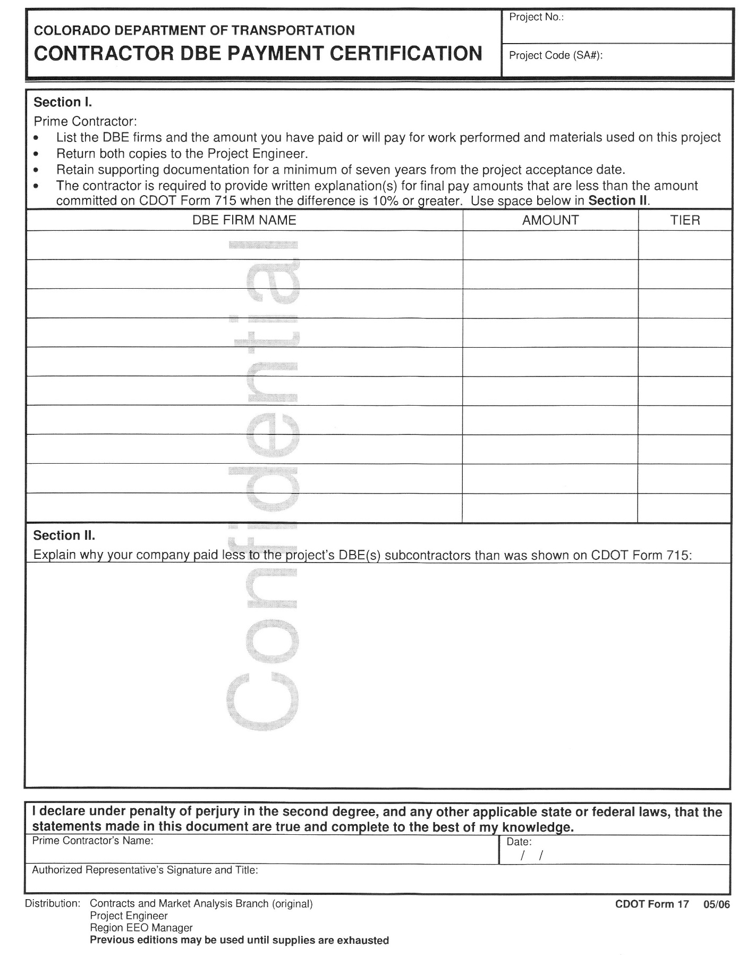
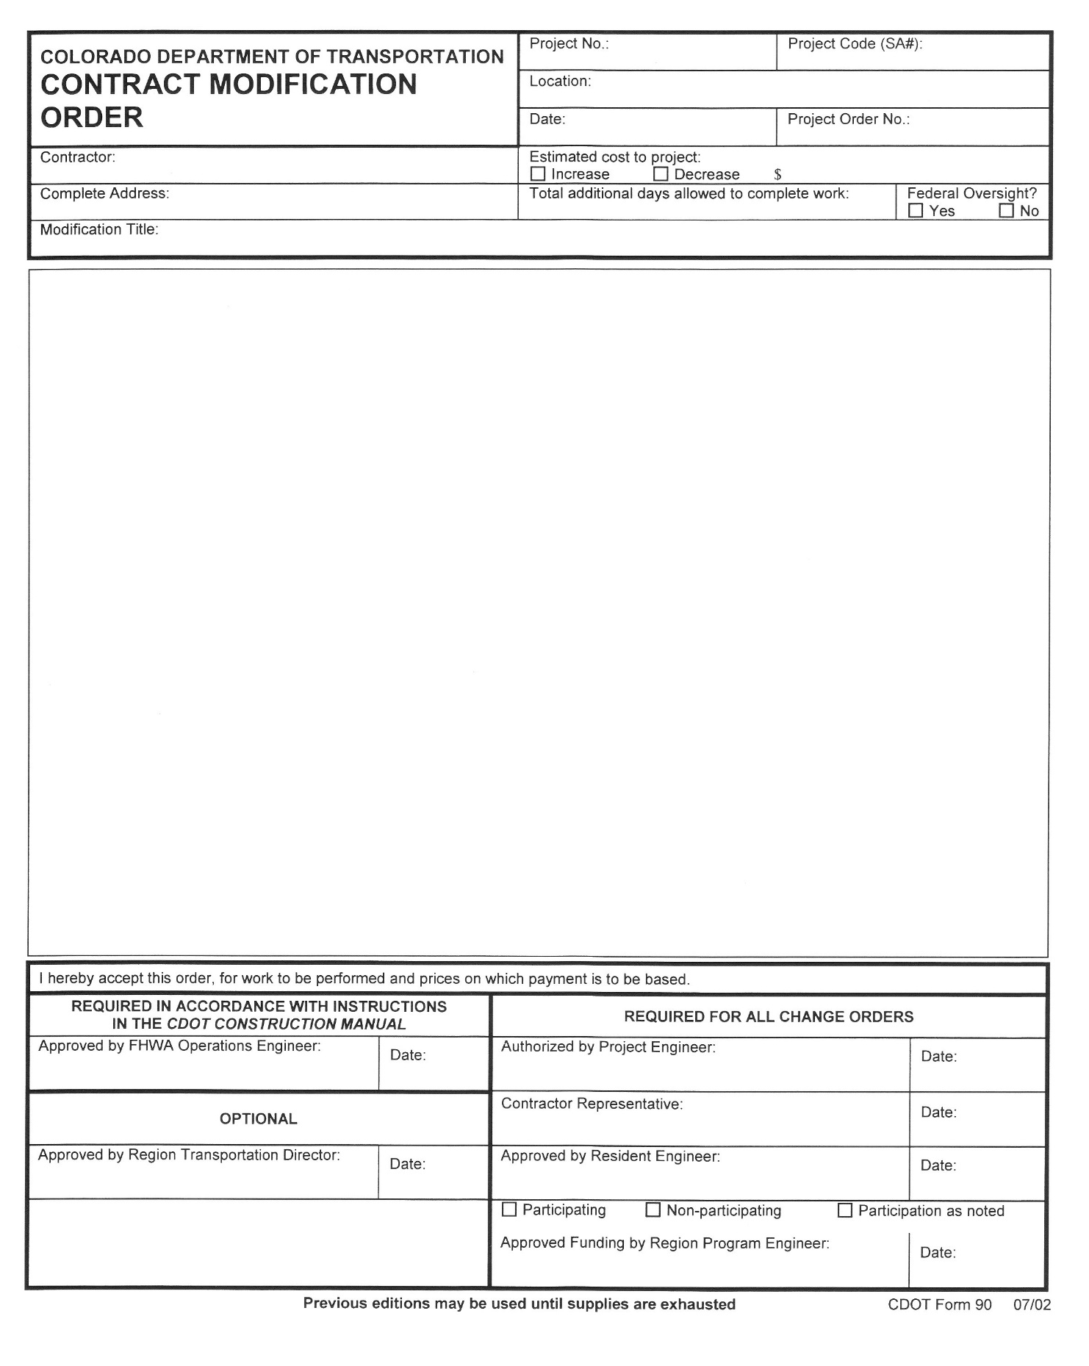
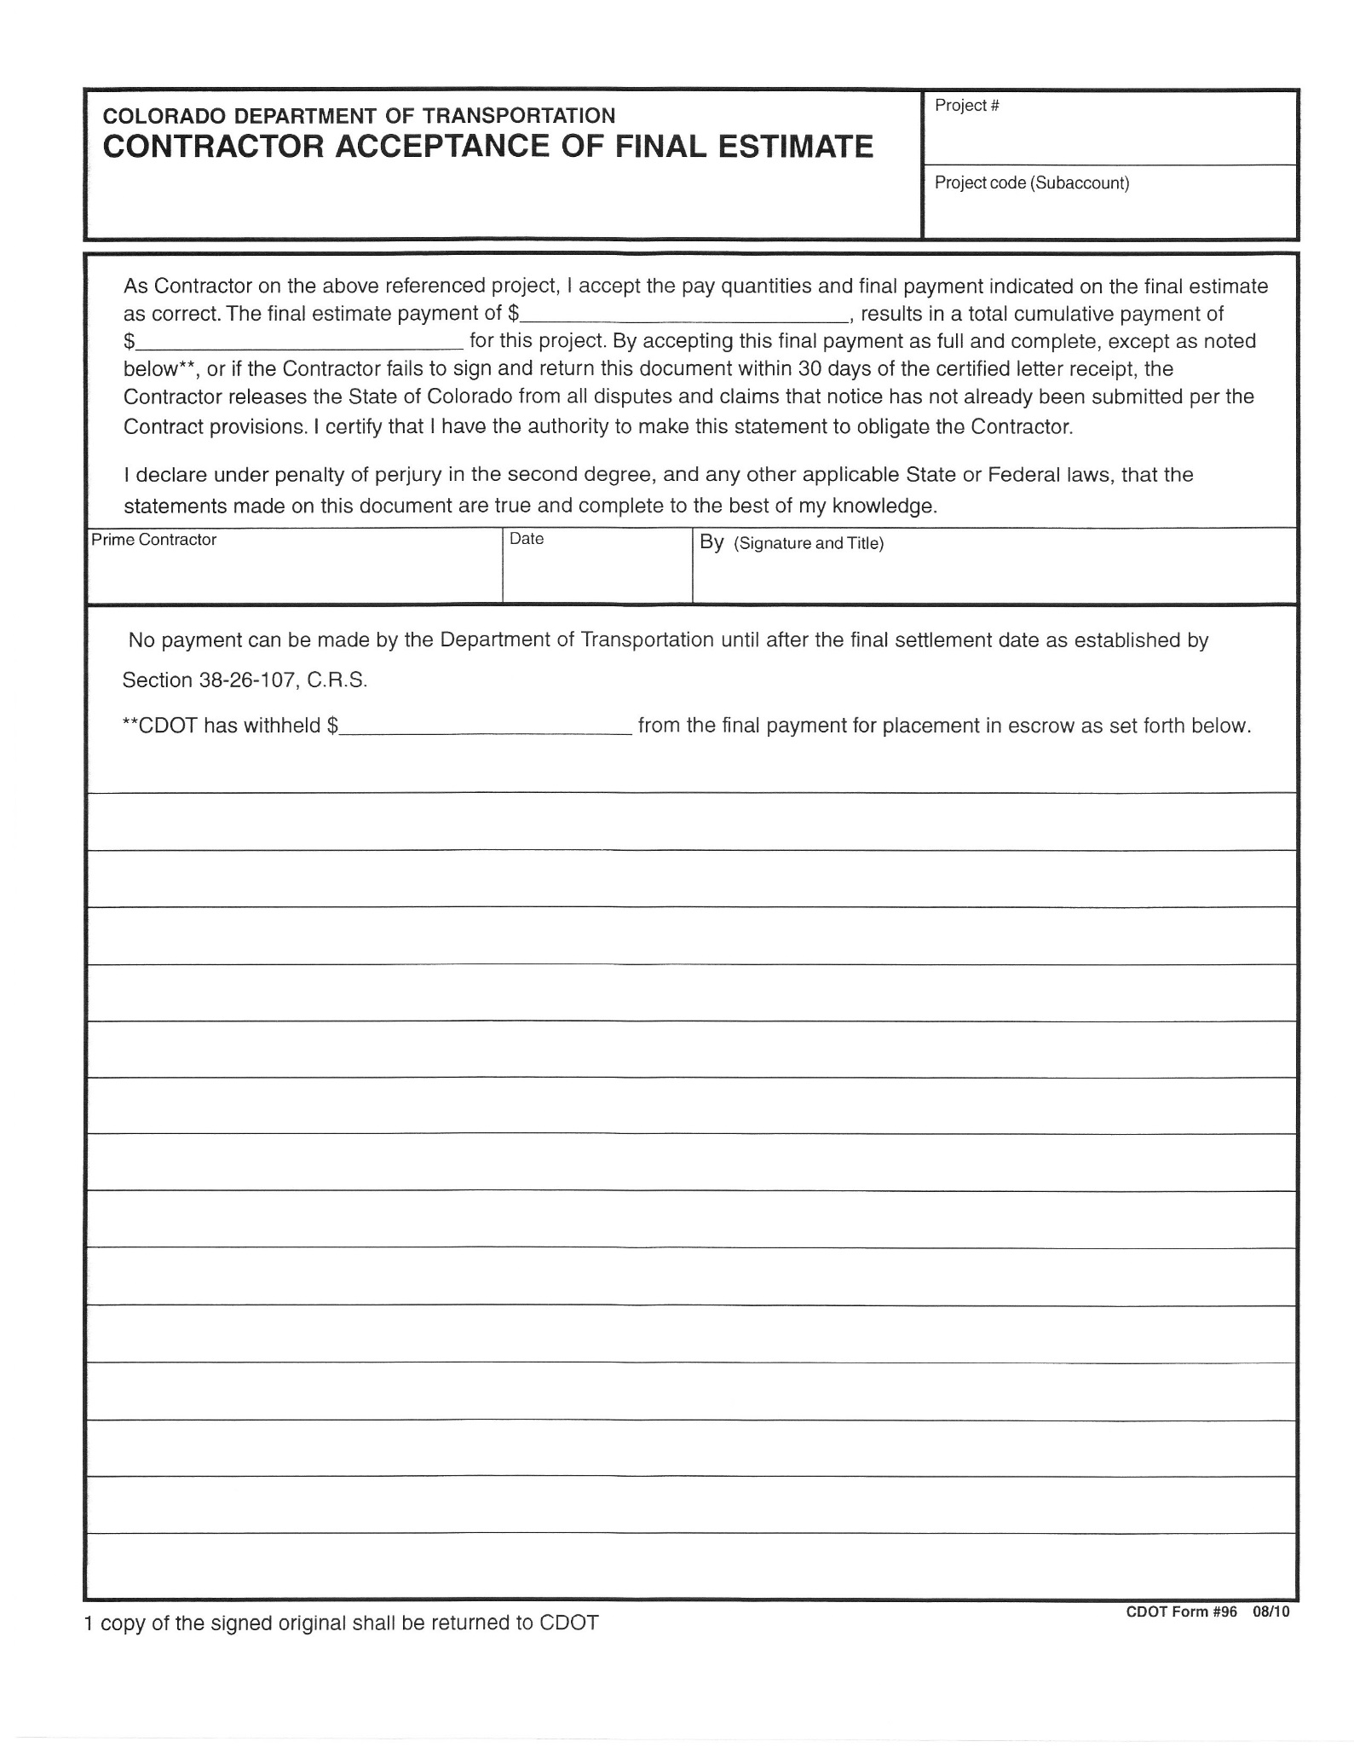

CDOT Form 1418 – Monthly Payment Summary
https://www.codot.gov/library/forms/cdot1418.pdf/view

CDOT Form 1419 – DBE Participation Report:
https://www.codot.gov/library/forms/cdot1419.xlsx/view

